**Arduino fingerprint System**

Required Components:

Arduino Mega

R305 Fingerprint Module

16 by 2 LCD with I2C Module

2-Pushbuttons

2-LEDs

2 K-ohm Resistors

Breadboard and Jumper Wires

SD card Module

**Wiring circuit**

Done using fritzing software:

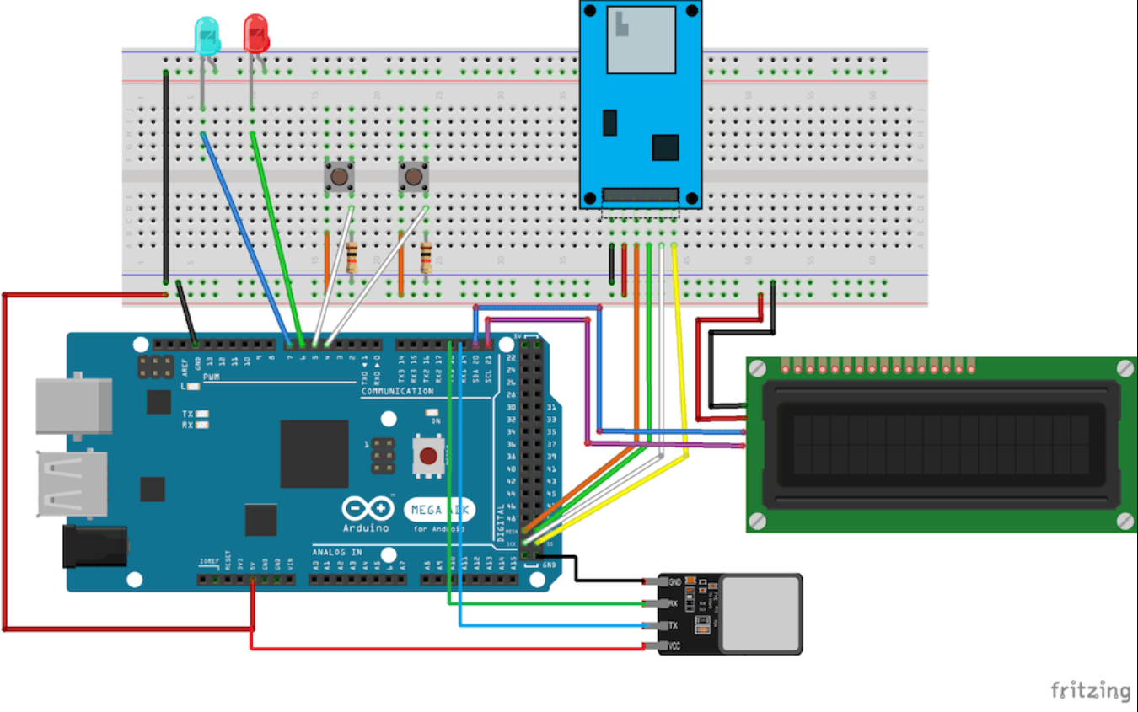

**Principle of Operation**

The R305/R307 fingerprint scanner has a TTL UART interface which can be directly connected to the Arduino UART.

The SD card module communicates with the Arduino over the serial peripheral interface (SPI) communication protocol. It can be simply connected to the Arduino’s hardware SPI pins.

The LCD module communicates with Arduino through I2C communication.

The fingerprint sensor and pushbuttons act as input modules. Here, I am using two pushbuttons for the enrollment and identification processes. When we want to enroll a new user, the registration button must be pressed to start the registration process. After pressing the attendance button, the finger will be verified to mark attendance. The LCD modules and LEDs act as output modules. They will print messages and errors to give the visible output of the process.

Fingerprints save in the flash memory of the fingerprint sensor. The R305 module itself performs fingerprint collection, comparison, and search. The ID of the verified fingerprint is saved in a text file on the SD card. We can use that attendance report by removing the microSD card from the module.